Protein That Protects Nucleus Also Regulates Stem Cell Differentiation

The human body has hundreds of different cell types, all with the same basic DNA, and all of which can ultimately be traced back to identical stem cells. Despite this fundamental similarity, a bone cell has little in common with a brain cell when it comes to appearance or function. The fact that bone is rigid and mechanically distinct from soft fat or brain had been speculated to play some role in differentiation to new cells in those parts of the body, but mechanisms have been unclear.
Now, a study by researchers at the University of Pennsylvania have shown that a protein found in the nuclei of all cells — lamin-A — plays a key role in the differentiation process.
The study was led by professor Dennis Discher and postdoctoral researchers Joe Swift and Irena Ivanovska of the Department of Chemical and Biomolecular Engineering in Penn’s School of Engineering and Applied Science.

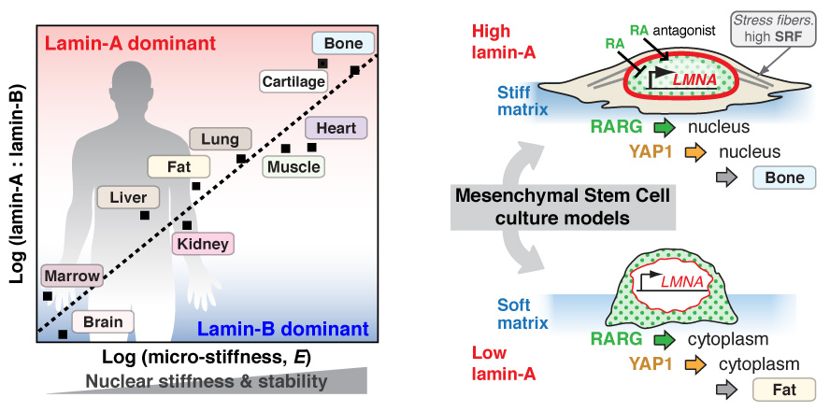

Lamin-A is a protein found in the nucleus of all adult cells. This rope-like protein forms a protective netting around the DNA contained at the core of the nucleus.
The first hint that lamin-A might be involved in regulating the stiffness of nuclei came from diseases that lead to abnormal protein. One such disease, progeria, has symptoms akin to premature aging, including brittle bones and muscle wasting. But while these stiff tissues are affected, soft tissues such as brain and blood remain normal.
As a self-assembling filament, lamin-A is like a rope in that, when it is pulled, it becomes taut. As this stiffness would be better suited to resisting the pull of neighboring cells, the researchers speculated that such a protein would be more abundant in tissues, like bone, cartilage and muscle, that need to be stiff to resist the stresses and strains of everyday activity.
“We hypothesized that higher levels of lamin-A in the nuclei of stiffer tissues would be appropriate to a greater need to prevent breakage of the precious DNA surrounded by the lamin-A net,” Discher said.
To determine how levels of lamin-A varied between cell types, the researchers took tissue cells from both mice and humans, broke the cells apart and fed them to a mass spectrometer to quantify the many protein components.
The researchers then looked for any correlation between the amounts of the numerous proteins detected and the elasticity of the source tissue. Since the material outside cells called extracellular matrix is known to be particularly abundant in stiff tissues like bone and cartilage, they expected to see correlations with matrix proteins like collagen. However, they also found evidence supporting their hypothesis that nuclear lamin-A levels also increase dramatically from softer to more rigid tissues.
“The mass spectrometry lets us look at and quantify hundreds of proteins at the same time,” Swift said. “Starting with brain and moving up through bone, we see lamin-A and collagen both increase relative to a similar ropelike protein, lamin-B, which is pretty much constant across cell types.”
The types of cells where lamin-B was more prevalent than lamin-A were the particularly squishy tissues, like brain and bone marrow. However, lamin-A dominates in stiffer tissues.
“Lamin-A levels are almost 30 times higher in bone than in brain,” Swift said.
Discher’s team did mechanical stress tests on the individual nuclei of these various tissues and showed that higher levels of lamin-A were correlated with greater protection of DNA and with added rigidity. In studying nuclei with healthy and mutant versions of lamin-A, the researchers uncovered an important role of biological modification of protein — a process called phosphorylation — in regulating levels of lamin-A.
“When cells divide, they split their DNA, but they first must dissolve the lamin net around the DNA, and this is done via phosphorylation,” Discher said. “What we know now is that tissue cells have co-opted this process to adjust lamin levels to nuclear stress.
“Lamin-related diseases may have abnormal regulation, as well,” he said.
While these experiments emphasize a structural role that lamin-A plays in the cell’s nucleus in relation to tissue stiffness, an additional role also became clear.
“We show that lamin-A is regulating gene expression through epigenetic mechanisms,” Ivanovska said. “It can catch certain transcription factors inside the nucleus.”
Transcription factors are proteins that move in and out of the nucleus to trigger protein production. Some of the transcription factors that lamin-A controls relate to a key vitamin A metabolite called retinoic acid, but this also regulates lamin-A production. This suggested a feedback loop that helps to drive increased nuclear stiffness.
Discher’s team tested both halves of this loop with in vitro experiments.
“We take mesenchymal stem cells and grow them on both soft and stiff substrates and then further change their lamin-A production levels using retinoic acid related compounds as well as RNA interference,” Ivanovska said.
By adding the right retinoic acid compounds to stem cells cultured on bone-like rigid matrices, the cells could be coaxed into making much more bone in a dish, but, when lamin-A was also silenced by RNA interference, bone induction on stiff matrix was repressed.
“When we knock down lamin-A in the stem cells growing on soft substrates akin to fat, we increased fat production,” Swift said. “Lamin-A has an amplification effect in differentiation.”
This systematic demonstration of the relationship between lamin-A, tissue stiffness and environmental signals that drive differentiation could pave the way for more effective regenerative medicine techniques and better drug targets. Given the role of lamin-A in aging as well as disease, manipulating its levels could be broadly important to human health

